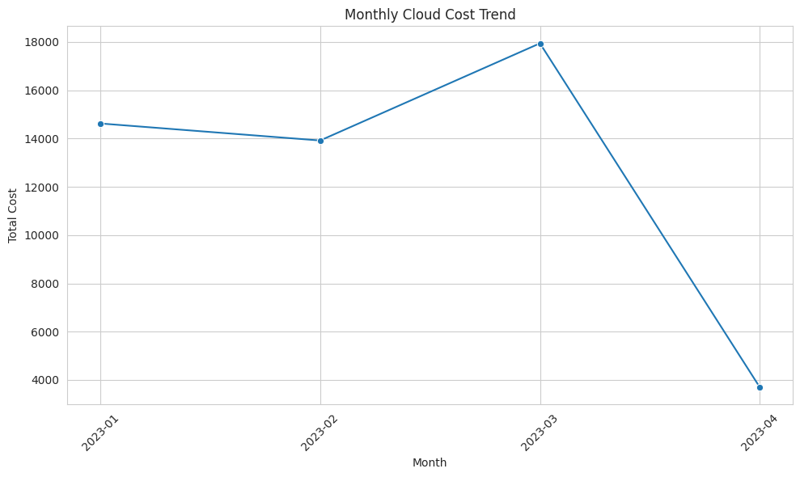
/tmp/ipython-input-781243932.py:20: FutureWarning:

Passing `palette` without assigning `hue` is deprecated and will be removed in v0.14.0. Assign the `x` variable to `hue` and set `legend=False` for the same effect.

sns.barplot(data=service_cost_sorted, x='Service', y='Cost', palette='viridis')
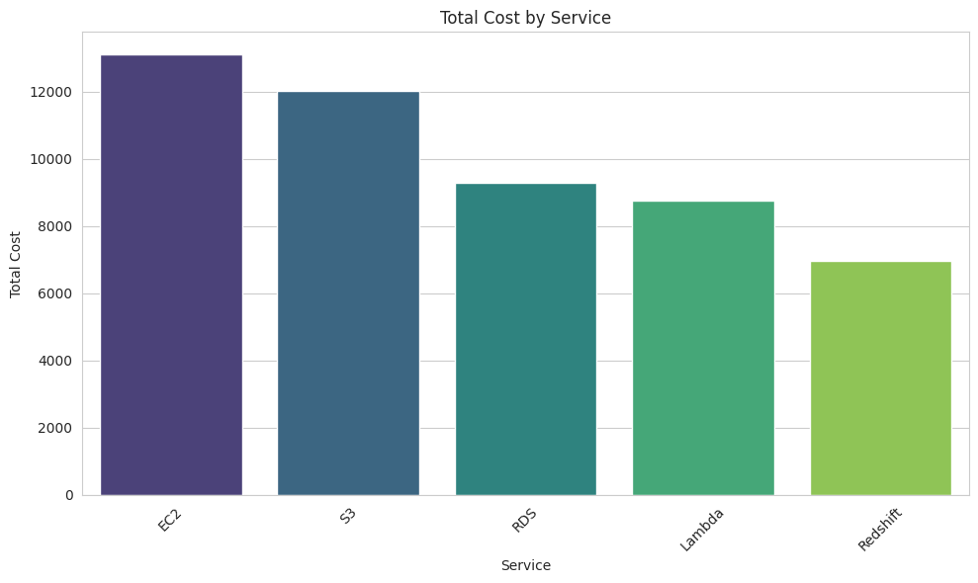
/tmp/ipython-input-781243932.py:31: FutureWarning:

Passing `palette` without assigning `hue` is deprecated and will be removed in v0.14.0. Assign the `x` variable to `hue` and set `legend=False` for the same effect.

sns.barplot(data=instance_type_cost_sorted, x='Instance_Type', y='Cost', palette='magma')
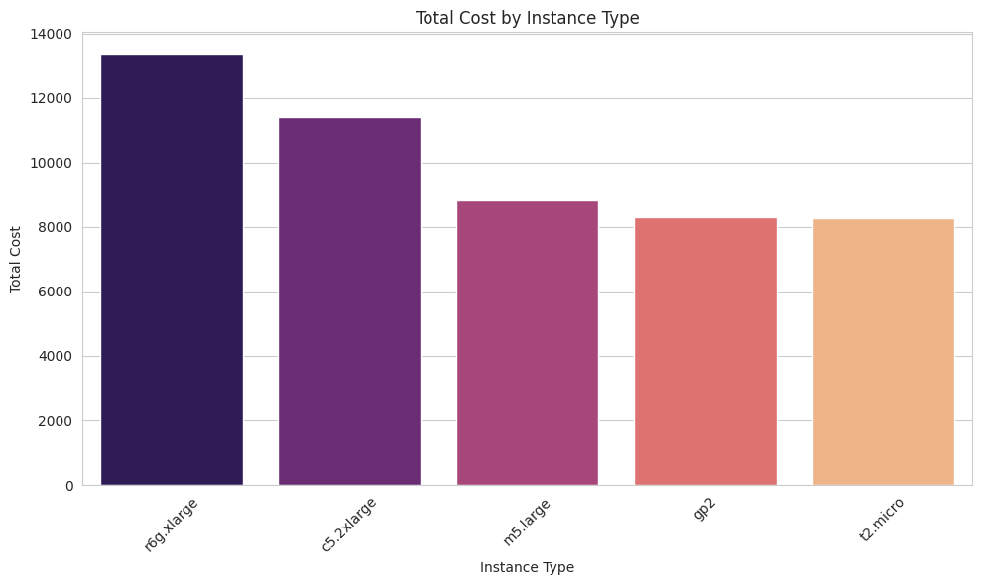
/tmp/ipython-input-781243932.py:42: FutureWarning:

Passing `palette` without assigning `hue` is deprecated and will be removed in v0.14.0. Assign the `x` variable to `hue` and set `legend=False` for the same effect.

sns.barplot(data=environment_cost_sorted, x='Environment', y='Cost', palette='cividis')
